**Assignment-1(String Functions)**

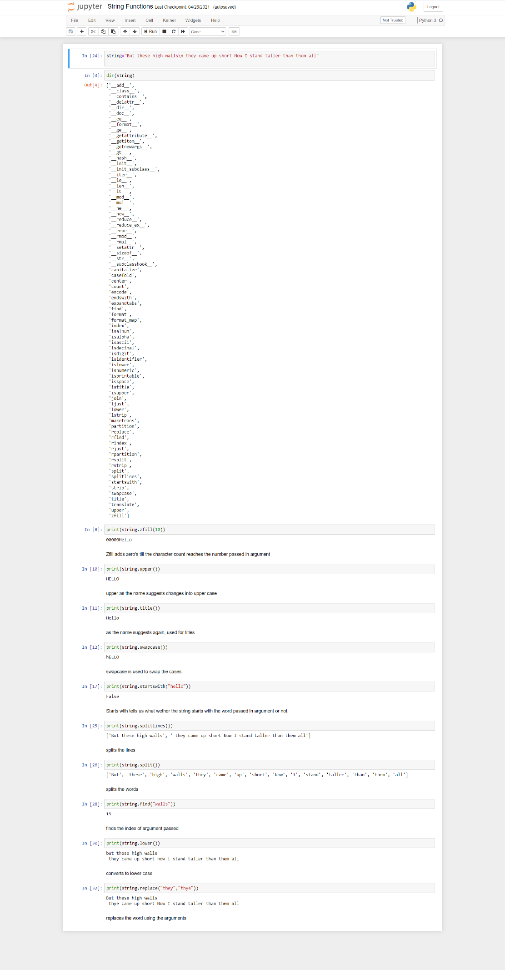

**Assignment-2(Numpy Ex)**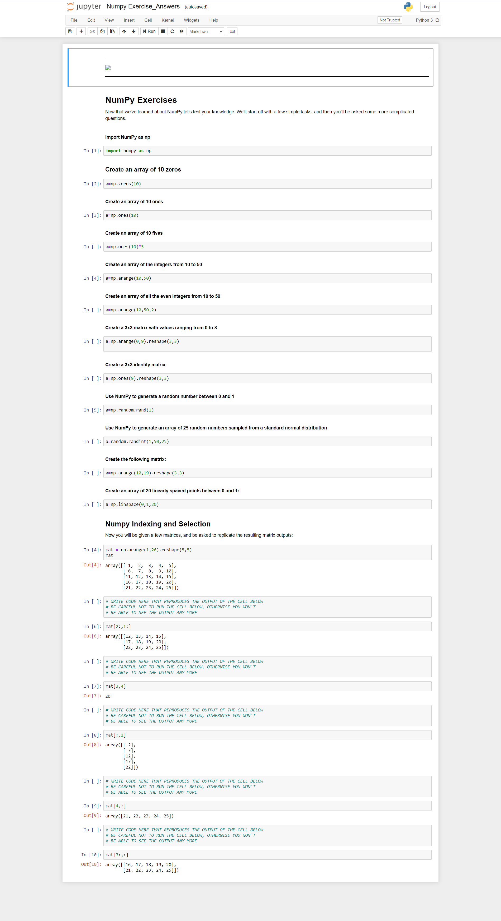

**Assignment -3(Iris)**

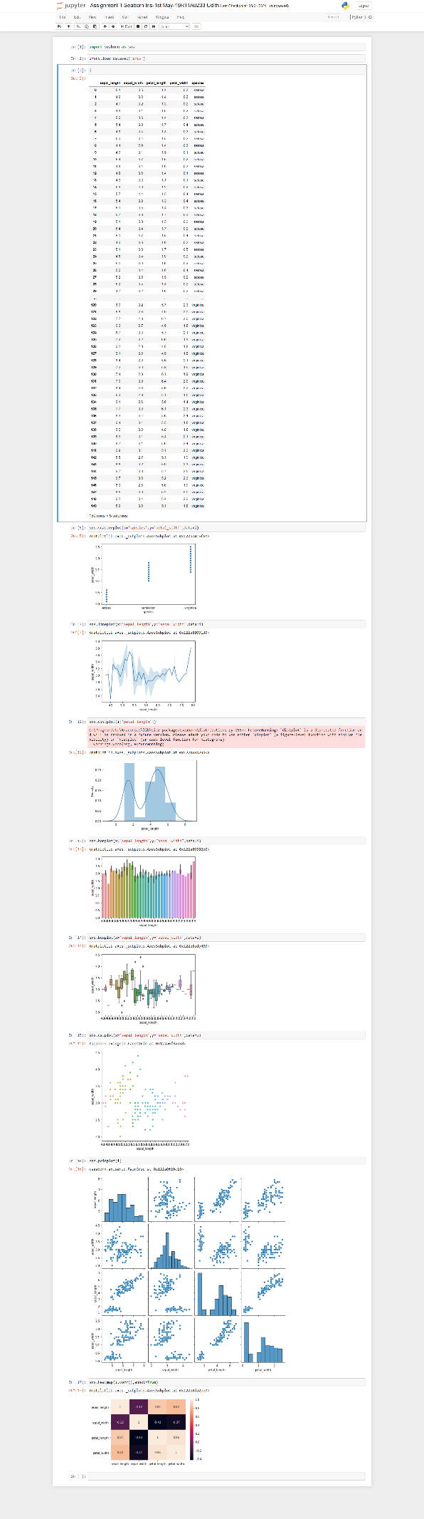

**Assignment-4-1 (Fish)**

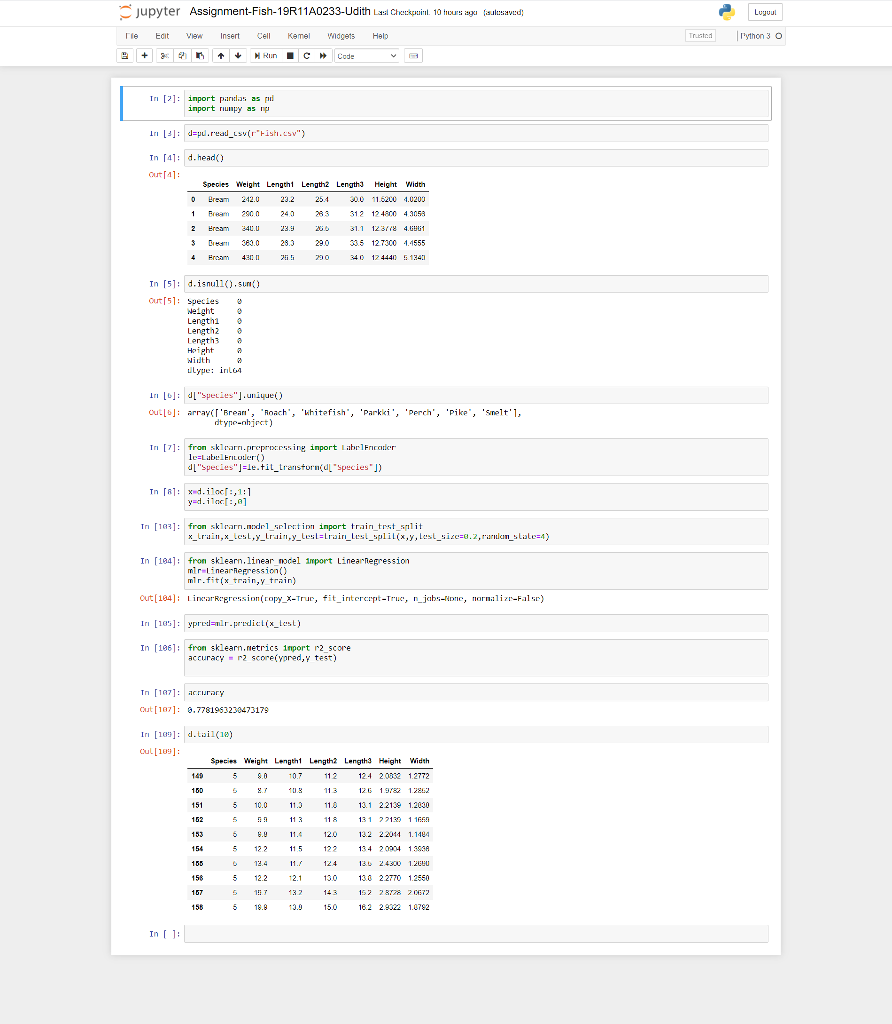

**Assignment 4-2(Bank)**

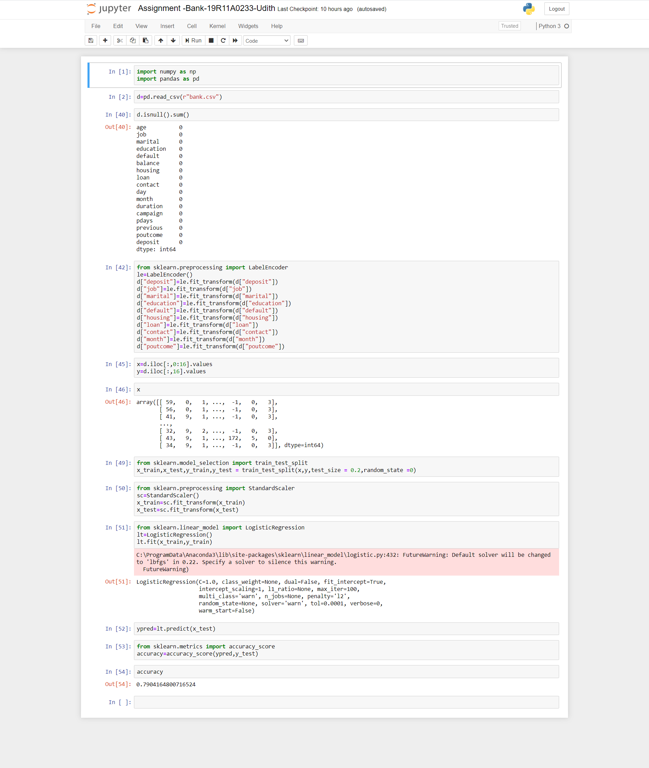

**Drive link for HD screenshots:** [**https://drive.google.com/drive/folders/12cJ7bZDHJCYEtqSWC6TunFcG6fnhk8lF?usp=sharing**](https://drive.google.com/drive/folders/12cJ7bZDHJCYEtqSWC6TunFcG6fnhk8lF?usp=sharing)